Tkinter Class Programs:

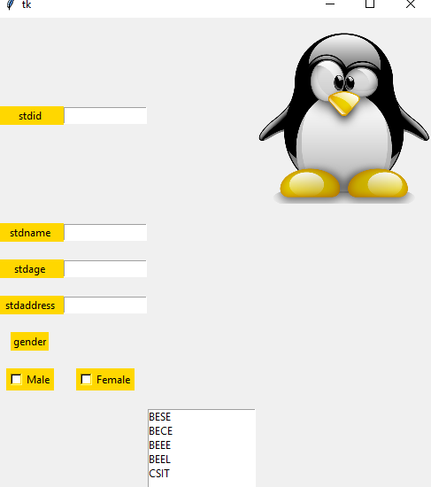

**from** tkinter **import**\*  
**from** tkinter **import** messagebox  
**def** data():  
 messagebox.showinfo(**'hello'**,id.get()+**'\n'**+name.get()+**'\n'**+age.get())  
m=Tk()  
l1=Label(m,text=**"stdid"**, bg=**"gold"**,fg=**"black"**,width=10).grid(row=0,column=0,pady=10)  
l2=Label(m,text=**"stdname"**, bg=**"gold"**,fg=**"black"**,width=10).grid(row=1,column=0,pady=10)  
l3=Label(m,text=**"stdage"**, bg=**"gold"**,fg=**"black"**,width=10).grid(row=2,column=0,pady=10)  
l4=Label(m,text=**"stdaddress"**, bg=**"gold"**,fg=**"black"**,width=10).grid(row=3,column=0,pady=10)  
id=Entry(m,width=15)  
id.grid(row=0,column=1,pady=10)  
name=Entry(m,width=15)

name.grid(row=1,column=1,pady=10)  
age=Entry(m,width=15)  
age.grid(row=2,column=1,pady=10)  
address=Entry(m,width=15)  
address.grid(row=3,column=1,pady=10)  
gender=Label(m,text=**'gender'**,bg=**"gold"**,fg=**"black"**).grid(row=4,column=0,pady=10)  
c1=Checkbutton(m,text=**"Male"**,bg=**"gold"**,fg=**"black"**).grid(row=5,column=0,pady=10)  
c2=Checkbutton(m,text=**"Female"**,bg=**"gold"**,fg=**"black"**).grid(row=5,column=1,pady=10)  
img1=PhotoImage(file=**r"e:\cartoon.png"**)  
img2=img1.subsample(2,2)  
l5=Label(m,image=img2)  
l5.grid(row=0,column=3,pady=10)  
  
li=Listbox(m)  
li.insert(0,**'BESE'**)  
li.insert(1,**'BECE'**)  
li.insert(2,**'BEEE'**)  
li.insert(3,**'BEEL'**)  
li.insert(4,**'CSIT'**)  
li.grid(row=6,column=2,pady=10)  
b1=Button(m,text=**"Submit"**,command=data).grid(row=7,column=0,pady=10)  
m.mainloop()

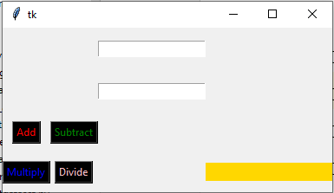

**from** tkinter **import**\*  
**from** tkinter **import** messagebox  
z=0  
**def** add():  
 x=op1.get()  
 y=op2.get()  
 z=int(x)+int(y)  
 v.config(text=z)  
 messagebox.showinfo(**"Result is"**,z)  
  
**def** subtract():  
 x = op1.get()  
 y = op2.get()  
 z = int(x) - int(y)  
 v.config(text=z)  
 messagebox.showinfo(**"Result is"**, z)  
  
**def** divide():  
 x=op1.get()  
 y=op2.get()  
 z=int(x)/int(y)  
 v.config(text=z)  
 messagebox.showinfo(**"Result is"**,z)  
  
**def** multiply():  
 x = op1.get()  
 y = op2.get()  
 z = int(x) * int(y)  
 v.config(text=z)  
 messagebox.showinfo(**"Result is"**, z)  
  
m=Tk()  
b1=Button(m,text=**"Add"**,bg=**'black'**,fg=**'red'**,command=add).grid(row=5,column=0,pady=10)  
b2=Button(m,text=**"Subtract"**,bg=**'black'**,fg=**'green'**,command=subtract).grid(row=5,column=1,pady=10)  
b3=Button(m,text=**"Multiply"**,bg=**'black'**,fg=**'blue'**,command=multiply).grid(row=6,column=0,pady=10)  
b4=Button(m,text=**"Divide"** ,bg=**'black'**,fg=**'pink'**,command=divide).grid(row=6,column=1,pady=10)  
op1=Entry(m)  
op1.grid(row=3,column=2,pady=15)  
op2=Entry(m)  
op2.grid(row=4,column=2,pady=15)  
v=Label(m,bg=**'gold'**,fg=**'blue'**,width=20)  
v.grid(row=6,column=7,pady=10)  
m.mainloop()

_____________________________________________________________